

School of Computer Engineering and Technology

T.Y. B.Tech

Year : 2022-2023 Semester : 5

Mini Project Report on :

“Courier Management System”

Submitted by

Ansh Mahajan 1032201496 PC36

Asmi Sinha 1032201441 PC33

Saksham Nargotra 1032201618 PC39

Under the Guidance of

Prof. Varsha Powar

At



School of Computer Engineering and Technology

# ABSTRACT

This **Courier Management System** Project will have different modules. While taking orders from its customers, it will take all the details of its customers who is placing the orders and all the details for the recipient such as its address, name, mobile number. Through the tracking id, customers or its recipient will able to track their products from any location using internet. It will provide status of the product after placing orders within 1 minute. The admin can manipulate the data through admin login page and add any new consignment if required. The profile section shows the data of the user and the ricing section of the project shows the price that will be charged for the consignment according to the weight categories.

Using the courier service person can easily send his/her parcel to other person in the particular destination within the time.

## TABLE OF CONTENTS

Abstract …………………………………………………………………………...…… I

List of Abbreviations ....………………………………………………………….….… II

List of Figures .………………………..…………………………………………….… III

List of Tables .………………………………………………………………..……..…. IV

1. Introduction .………………………………………………………………................... 6
   1. Motivation .…………………………………………………………………………..... 6
   2. Objectives ……………………………………………………………………............... 6
2. Problem Definition ..……………………………………………………………..……. 7
3. Tools and Technologies ..………………………………………………………..…...... 8
4. Database Design ..……………………………………………………………….…...... 9

ER Diagram ..………………………………………………………………………...... 9

1. Database Schema ..…………………………………………………………………… 10
   1. Schema Diagram.……………………………………………………………….……...10
   2. Relationship Schema.…………………………………………………………………..11
   3. Database Normalization till 3NF.…………………………………………….………...11

## LIST OF ABBREVIATIONS

NodeJS -BackEnd

MySQL- My Structured Query Language

JSP- Java Server Pages

PK- Primary Key

FK- Foreign Key

## LIST OF FIGURES

1. ER DIAGRAM
2. RELATIONSHIP SCHEMA

## LIST OF TABLES

1. Admin
2. Sender
3. Reciever
4. Shipment
5. Courier
6. Bill

## INTRODUCTION

1.1 MOTIVATION

To gain maximum business region, customer demands good service. So to make more profit

And gain maximum business region, their administration must also have a system to tackle all

these problems on time. Its administration can take immediate orders and provide a receipt

which will include all the details of the products along with appropriate price to their

customers. Thus saving time and eliminating line making process.

1.2 OBJECTIVE

The main objective of the application is

• In computer system of the courier service computation of the rate is easily & quickly

done.

• Computer system of the courier service provide fast access.

• In computer system the person has to fill the various forms & number of copies of the

forms can be easily generated at a time.

• In computer system, it is not necessary to create the Manifest but we can directly print it,

which saves our time.

• It contain better storage capacity.

• Accuracy in work.

## 2. PROBLEM DEFINITION

This Courier Management System Project will have different modules. The login section will

have login facility for the admin and for the user who will operate this system. While taking

orders from its customers, it will take all the details of its customers who is placing the orders

and all the details for the recipient such as its address, name, mobile number. During billing

process system will generate a tracking id for their products. Through this tracking id,

customersor its recipient will able to track their products from any location using internet. It

will providestatus of the product after placing orders within 1 minute.

The courier service is one of the solutions of these problems. It is used to send some things to

any person in the world within time.The courier company has number of branches, which are

spread over the country or the world.So that when person wants to send things then he has to

contact at nearest courier service branch.The courier company creates the schedule & gives

internal/external services. The courier service work as destination office or source office.

In modern age, as time increase, needs & requirements of the person are also increased. They

want more facility & try to do their task quickly & within time. But they can not get all the

things at nearest market or area, so they have to import the things from any place in the world.

Within the country, the things can be imported through post service. But it consumes the time

&sometimes problem of damage or missing occur. Where as in the international market, the

oneway is shipping. But it also requires more time.

## 3. TOOLS AND TECHNOLOGIES

**Software Requirement:**

• Node.js

• MySQL Version 8.0.31 or above

• Latest browser : Chorme, Firefox, Safari etc

• Operating System : Any (Linux, Windows, Mac etc)

**Hardware Requirements:**

• Processor Pentium IV or higher version.

• Ram 2GB or above

• Hard Disk 512GB or above

## 4. DATABASE DESIGN

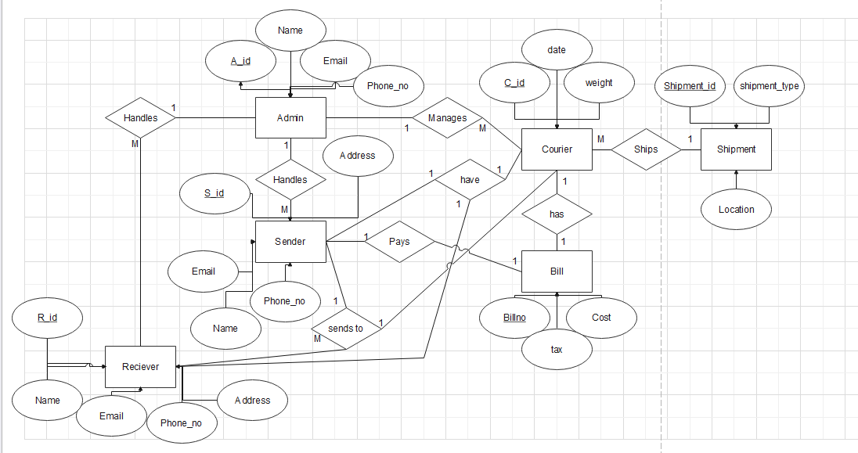4.1 ER Diagram

## 5. DATABASE SCHEMA

5.1 Relationship Schema

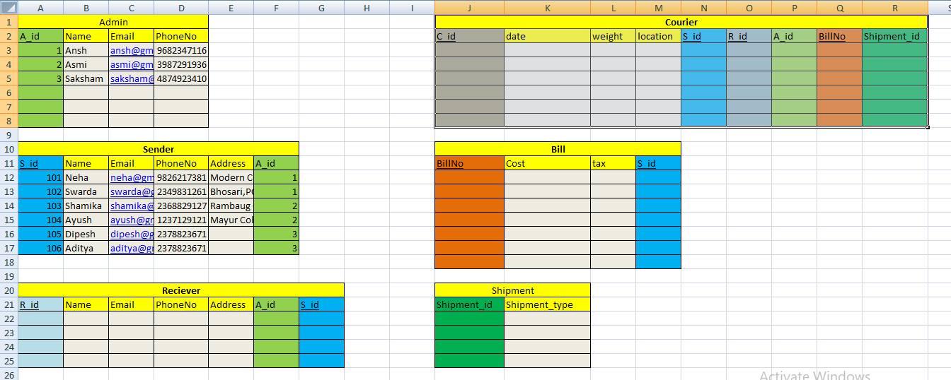

5.3 Database Normalization till 3NF

1. Every attribute in each relation is atomic. (1NF)
2. There exists no partial dependency in any of the relations. i.e all non-key attributes are fully functionally dependent on the primary key.(2NF)
3. There exists no transitive dependency for non-key attributes in any of the relations.(3NF)